

VIETNAMESE STUDY SYSTEM FOR JAPANESE

Screen Design

**Project Code: Veazy**

**Document Code: Veazy_ Screen_Design_v1.1_EN**

**Ha Noi, 06/10/2016**

Record of change

*A - Added M - Modified D – Deleted

|  |  |  |  |  |
| --- | --- | --- | --- | --- |
| **Effective Date** | **Changed Items** | **A* M, D** | **Change Description** | **New Version** |
| 06/10/2016 | Screen design | A | Add screens | v1.0 |
| 06/30/2016 | Screen design | M | Update screens | v1.1 |
|  |  |  |  |  |

Table 1. Records of changes

**Signature page**

**Originator** Nguyen Hong Quan 05/08/2014

Developer

**Reviewer** Nguyen Trong Duy 06/08/2014

Developer

**Approval** Nguyen Van Sang 06/08/2014

Supervisor

Table of Contents

1 Introduction 5

1.1 Purpose 5

1.2 Definitions, Acronyms and Abbreviations 5

1.3 Overview 5

2 Screen Flow 6

2.1 Common user 7

2.1.1 Homepage 7

2.1.2 Login 9

2.1.3 Recovering Password 10

2.1.4 Register 11

2.1.5 Lessons List 13

2.1.6 Lesson Detail 14

2.1.7 Test 16

2.1.8 Article List 17

2.1.9 Article Detail 18

2.2 Common user (logged in) 19

2.2.1 User Profile 19

2.2.2 Test Statistics 20

2.3 Content creator 21

2.3.1 Lesson List 21

2.3.2 Lesson Detail 21

2.3.3 Adding Lesson 21

2.3.4 Editing Lesson 23

2.3.5 Question List 25

2.3.6 Question Detail 26

2.3.7 Adding question 27

2.3.8 Editing Question 32

2.4 Content manager 37

2.5 Admin 37

2.5.1 Admin Dashboard 37

2.5.2 Member List 38

2.5.3 Report List 39

3 Other considerations 40

# Introduction

## Purpose

The purpose of this document is to ensure the consistency as well as the simplicity in detailed design across all displays within Veazy interface. Screen design describes the process of designing layout and appearance of Veazy web page so that it is engaging to readers and easy to use.

## Definitions, Acronyms and Abbreviations

|  |  |  |
| --- | --- | --- |
| Abbreviations | Description | Comment |
| Veazy | Vietnamese Study System for Japanese |  |
| Q&A | Question and Answer |  |

Table 2. Acronyms & Abbreviations

## Overview

Image of web page here

# Screen Flow

SCREEN FLOW HERE

|  |  |  |
| --- | --- | --- |
| No | Screen Name | Description |
| 1 | Homepage | Homepage |
| 2 | Login | Logging into Veazy system with a registered account |
| 3 | Register | Registering new account |
| 4 | Recovering Password | Recovering lost password |
| 5 | Lesson List | Displaying list of available lessons in a study course |
| 6 | Lesson Detail | Displaying lesson content |
| 7 | Test | Setting up and doing test |
| 8 | Article List | Displaying article list |
| 9 | Article Detail | Displaying article content |
| 11 | User Profile | Displaying detailed information of user |
| 12 | Test Statistics | Displaying statistics assessed based on test results |
| 13 | Content Manager Dashboard |  |
| 14 | Content Creator Dashboard |  |
| 15 | Lesson List (for content manager & content creator) | Displaying lesson list |
| 16 | Lesson Detail (for content manager & content creator) | Displaying lesson detail |
| 17 | Adding Lesson | Creating new lesson |
| 18 | Editing Lesson | Editing lesson content |
| 19 | Question List | Displaying list of questions intended to be generated in test |
| 20 | Question Detail | Displaying question content |
| 21 | Admin Dashboard |  |
| 22 | Member List | Displaying list of Veazy members |
| 23 | Report List | Displaying report sent by Veazy members |

## Common user

### Homepage

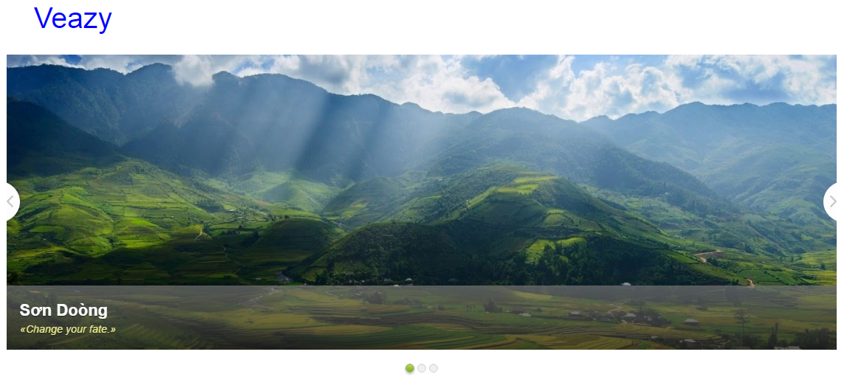

Figure 1. Homepage (1)

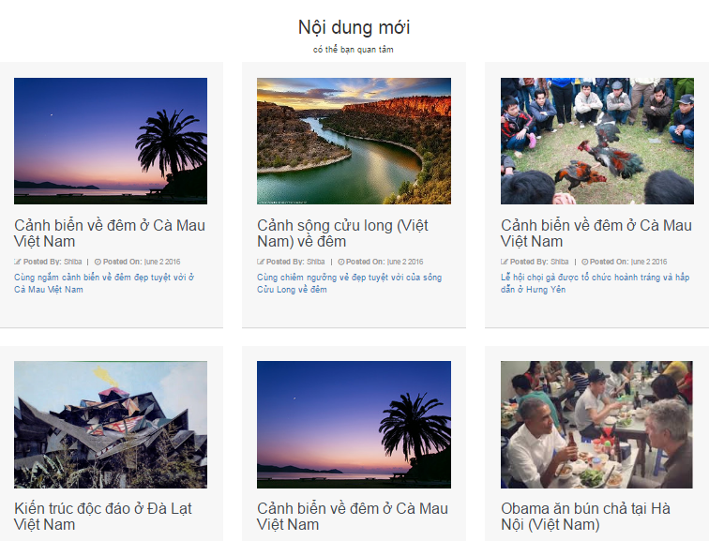

Figure 2. Homepage (1)

|  |  |  |  |  |  |  |  |
| --- | --- | --- | --- | --- | --- | --- | --- |
| **No** | **Field name** | **Format** | **Require** | **Mandatory** | **Min**  **length** | **Max**  **length** | **Description** |
| 1 | Veazy | Hyperlink | Click | N |  |  | User clicks to navigate to Homepage |
| 2 | Home | Hyperlink | Click | N |  |  | User clicks to navigate to Homepage |
| 3 | Courses | Dropdown | Select | N |  |  | User selects a course to navigate to Lesson List page |
| 4 | Test | Hyperlink | Click | N |  |  | User clicks to navigate to Test page |
| 5 | Reading | Hyperlink | Click | N |  |  | User clicks to navigate to Article List page |
| 6 | Login | Hyperlink | Click | N |  |  | User clicks to navigate to Login page |

Table 4. Homepage's component

### Login

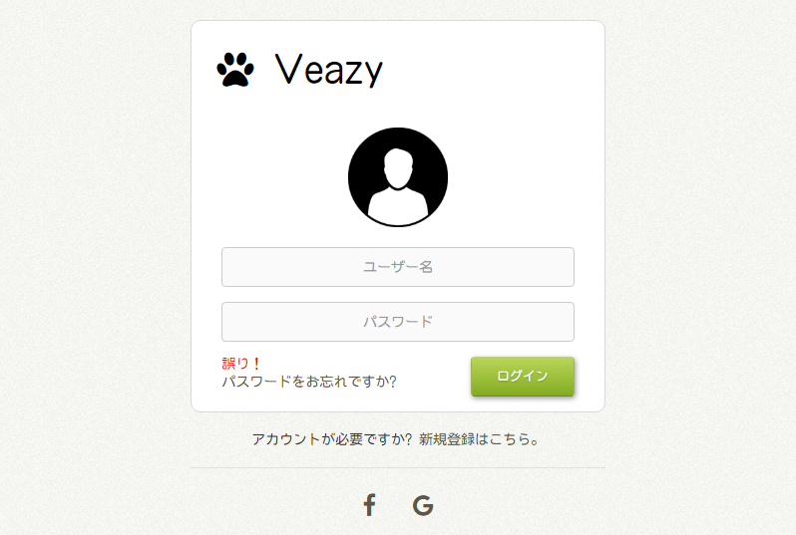

Figure 3. Login page

|  |  |  |  |  |  |  |  |
| --- | --- | --- | --- | --- | --- | --- | --- |
| **No** | **Field name** | **Format** | **Require** | **Mandatory** | **Min**  **length** | **Max**  **length** | **Description** |
| 1 | Veazy | Hyperlink | Click | N |  |  | User clicks to return to Homepage |
| 2 | Username | Text | Input | Y |  |  | User inputs username |
| 3 | Password | Password | Input | Y |  |  | User inputs password |
| 4 | Login | Button | Click | Y |  |  | User clicks to login and are redirected to Homepage (for learners) or Dashboard (for admin, content creators & content managers) |
| 5 | Forgot password? | Hyperlink | Click | N |  |  | User clicks to navigate to Recovering Password page |
| 6 | Register | Hyperlink | Click | N |  |  | User clicks to navigate to Register page |
| 7 | Facebook icon | Hyperlink | Click | N |  |  | User clicks to log in using Facebook account |
| 8 | Google icon | Hyperlink | Click | N |  |  | User clicks to login using Google account |

Table 5. Login page's component

### Recovering Password

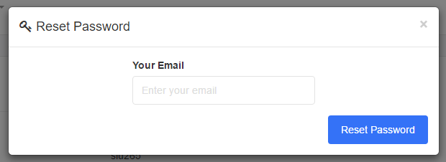

Figure 4. Recovering Password page

|  |  |  |  |  |  |  |  |
| --- | --- | --- | --- | --- | --- | --- | --- |
| **No** | **Field name** | **Format** | **Require** | **Mandatory** | **Min**  **length** | **Max**  **length** | **Description** |
| 1 | Email | Email | Input | Y |  |  | User inputs the email linked with current account |
| 2 | Reset password | Button | Click | Y |  |  | User click to recover the password |

Table 6. Recovering Password page's component

### Register

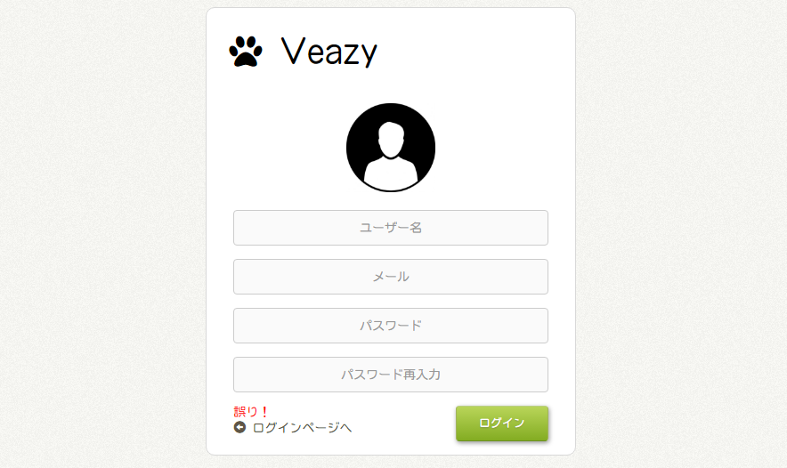

Figure 5. Register page

|  |  |  |  |  |  |  |  |
| --- | --- | --- | --- | --- | --- | --- | --- |
| **No** | **Field name** | **Format** | **Require** | **Mandatory** | **Min**  **length** | **Max**  **length** | **Description** |
| 1 | Veazy | Hyperlink | Click | N |  |  | User clicks to return to Homepage |
| 2 | Username | Text | Input | Y |  |  | User inputs username |
| 3 | Email | Email | Input | Y |  |  | User inputs email |
| 4 | Password | Password | Input | Y |  |  | User inputs password |
| 5 | Re-input password | Hyperlink | Input | Y |  |  | Users re-input password |
| 6 | Register | Button | Click | Y |  |  | User clicks to register new account |
| 8 | Return to login page | Hyperlink | Click | N |  |  | User clicks to return to Login page |

Table 7. Register page's component

### Lessons List

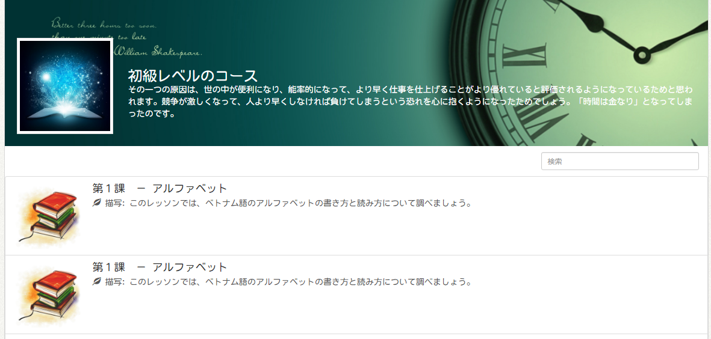

Figure 6. Lessons List page

|  |  |  |  |  |  |  |  |
| --- | --- | --- | --- | --- | --- | --- | --- |
| **No** | **Field name** | **Format** | **Require** | **Mandatory** | **Min**  **length** | **Max**  **length** | **Description** |
| 1 | Lesson name | Hyperlink | Click | N |  |  | User clicks to navigate to Lesson Detail page |
| 2 | Filter lesson | Input | Input | N |  |  | User inputs a keyword to filter lessons that contain the keyword in their contents |

Table 8. Lesson List page's component

### Lesson Detail

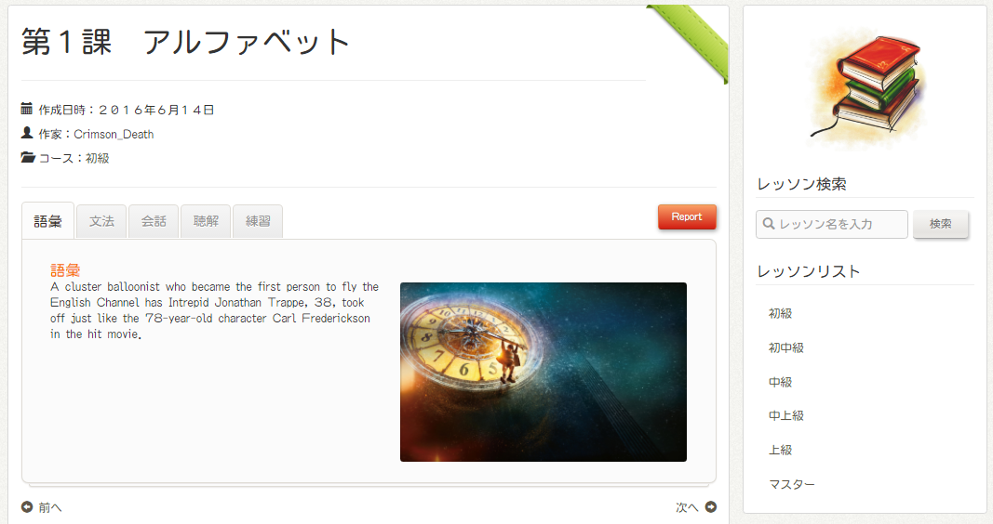

Figure 7. Lesson Detail

|  |  |  |  |  |  |  |  |
| --- | --- | --- | --- | --- | --- | --- | --- |
| **No** | **Field name** | **Format** | **Require** | **Mandatory** | **Min**  **length** | **Max**  **length** | **Description** |
| 1 | Course | Hyperlink | Click | N |  |  | User clicks to navigate to Lesson List page of the corresponding course |
| 2 | Vocabulary | Tab | Click | N |  |  | User clicks to display the vocabulary section |
| 3 | Grammar | Tab | Click | N |  |  | User clicks to display the grammar section |
| 4 | Conversation | Tab | Click | N |  |  | User clicks to display the conversation section |
| 5 | Practice | Tab | Click | N |  |  | User clicks to display the practice section |
| 6 | Report | Button | Click | N |  |  | User clicks to report lesson content |
| 7 | Previous lesson | Hyperlink | Click | N |  |  | User clicks to display content of the lesson before |
| 8 | Next lesson | Hyperlink | Click | N |  |  | User clicks to display content of the lesson after |
| 9 | Search lesson | Text | Input | N |  |  | User inputs a keyword and press Enter key to display lessons which contain the keyword in their content |
| 10 | Search lesson | Button | Click | N |  |  | User clicks to search lesson with input keyword |

Table 9. Lesson Detail page's component

### Test

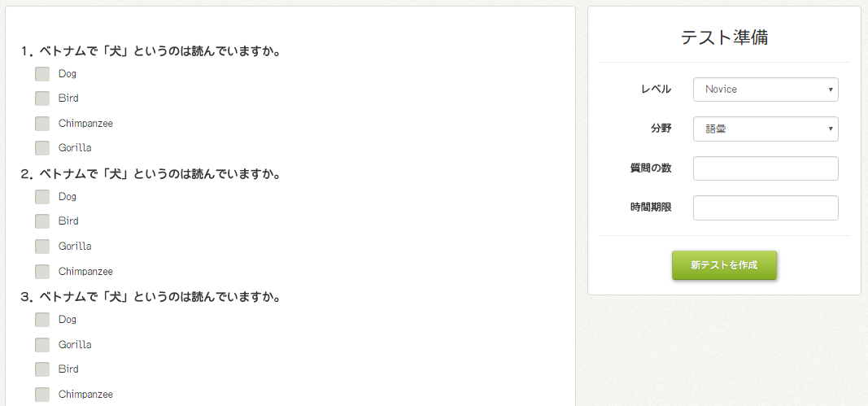

Figure 8. Test page

|  |  |  |  |  |  |  |  |
| --- | --- | --- | --- | --- | --- | --- | --- |
| **No** | **Field name** | **Format** | **Require** | **Mandatory** | **Min**  **length** | **Max**  **length** | **Description** |
| 1 | Level | Select box | Select | Y |  |  | User selects difficulty level |
| 2 | Skill | Select box | Select | Y |  |  | User selects the skill to be tested |
| 3 | Number of question | Number | Input | Y | 20 |  | User inputs number of questions test |
| 4 | Start test | Button | Click | Y |  |  | User clicks to generate a new test and start doing |
| 5 | Answer | Radio button | Click | Y |  |  | User clicks to choose the correct answer |
| 6 | Submit | Button | Click | Y |  |  | User clicks to submit the answer and display results |

Table 10. Test page's component

### Article List

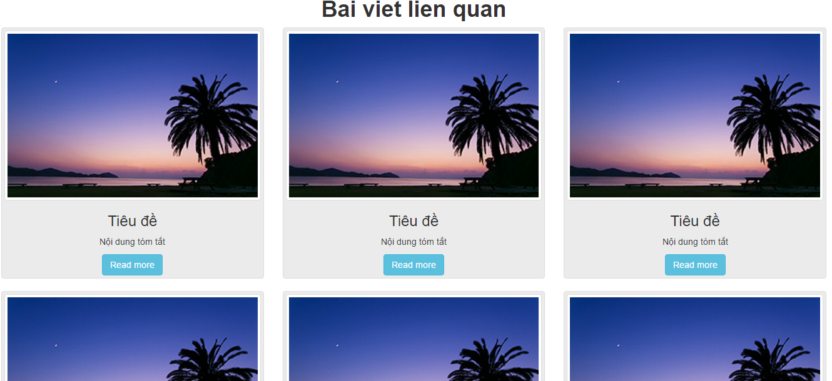

Figure 9. Article List page

|  |  |  |  |  |  |  |  |
| --- | --- | --- | --- | --- | --- | --- | --- |
| **No** | **Field name** | **Format** | **Require** | **Mandatory** | **Min**  **length** | **Max**  **length** | **Description** |
| 1 | Read more | Button | Click | N |  |  | User clicks to navigate to Article Detail page |

Table 11. Article List page's component

### Article Detail

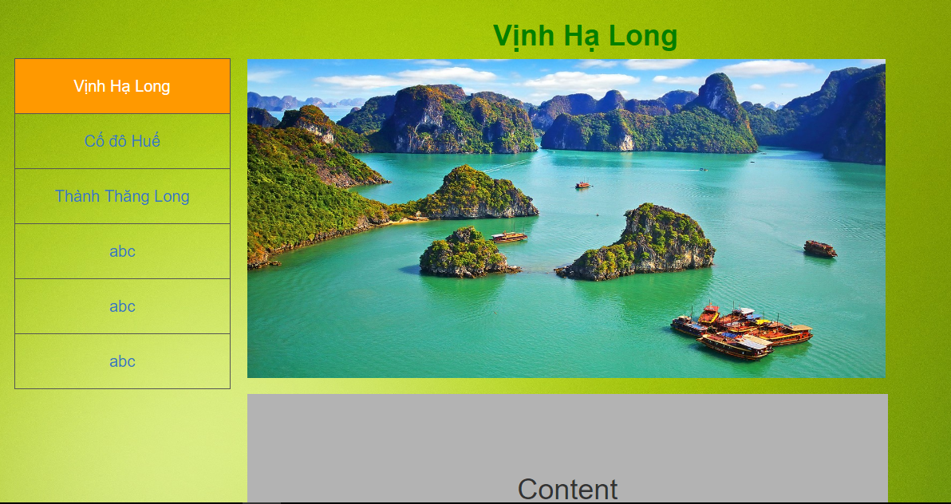

Figure 10. Article Detail page

|  |  |  |  |  |  |  |  |
| --- | --- | --- | --- | --- | --- | --- | --- |
| **No** | **Field name** | **Format** | **Require** | **Mandatory** | **Min**  **length** | **Max**  **length** | **Description** |
| 1 | Article name | Hyperlink | Click | N |  |  | User clicks to display content of the selected article |

Table 12. Article Detail page's component

## Common user (logged in)

### User Profile

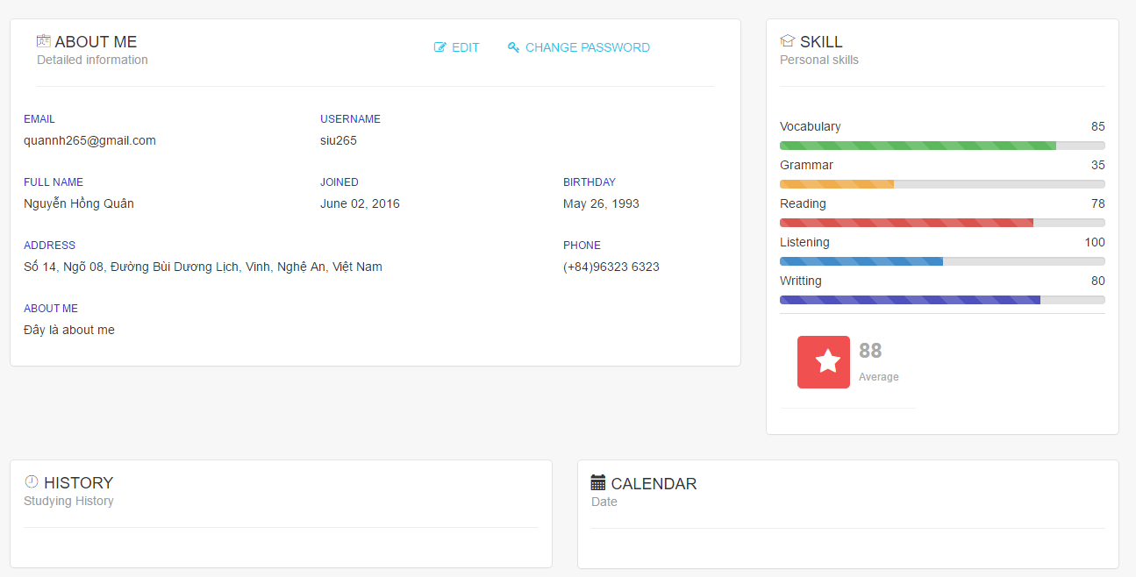

Figure 11. User Profile page

|  |  |  |  |  |  |  |  |
| --- | --- | --- | --- | --- | --- | --- | --- |
| **No** | **Field name** | **Format** | **Require** | **Mandatory** | **Min**  **length** | **Max**  **length** | **Description** |
| 1 | Edit | Hyperlink | Click | N |  |  | User clicks to enable editing detailed information |
| 2 | Change password | Hyperlink | Click | N |  |  | User clicks to enable changing password |

Table 13. User Profile page's component

### Test Statistics

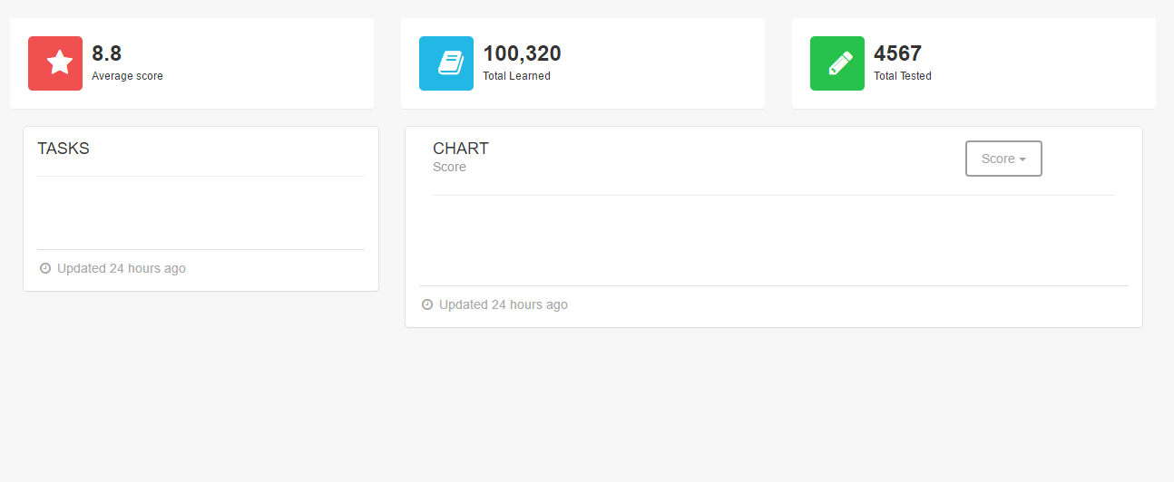

Figure 12. Test Statistics page

|  |  |  |  |  |  |  |  |
| --- | --- | --- | --- | --- | --- | --- | --- |
| **No** | **Field name** | **Format** | **Require** | **Mandatory** | **Min**  **length** | **Max**  **length** | **Description** |
| 1 | Score | Dropdown box | Click | N |  |  | User clicks to change the type of statistics to be displayed |

Table 14. Test Statistics page's component

## Content creator

### Lesson List

### Lesson Detail

### Adding Lesson

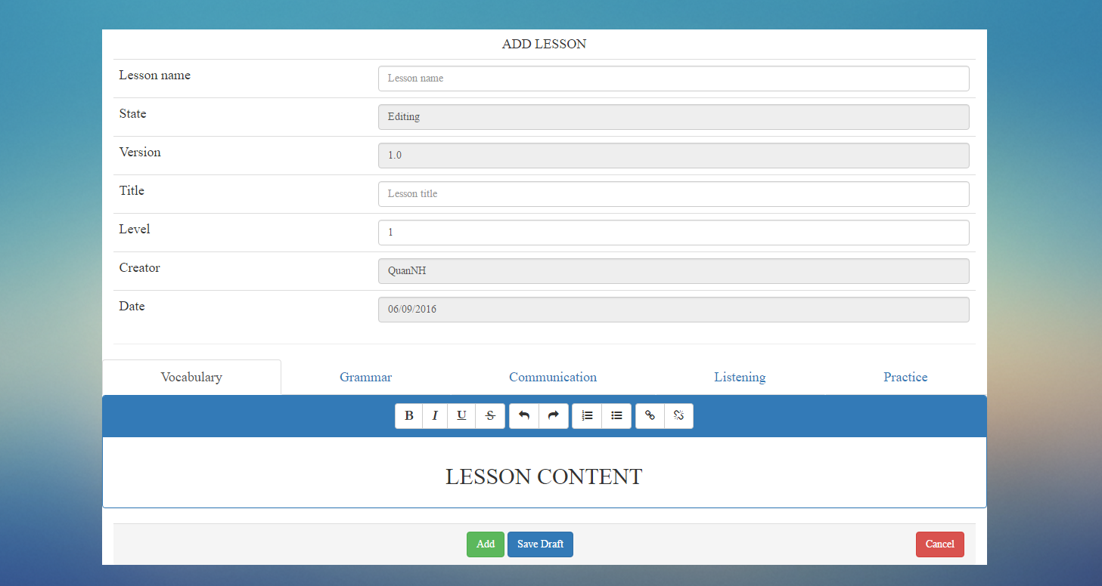

Figure 13. Adding Lesson page

|  |  |  |  |  |  |  |  |
| --- | --- | --- | --- | --- | --- | --- | --- |
| **No** | **Field name** | **Format** | **Require** | **Mandatory** | **Min**  **length** | **Max**  **length** | **Description** |
| 1 | Title | Text | Input | Y |  |  | User inputs lesson title |
| 2 | State | Text |  | Y |  |  | Displaying current state of lesson (auto-generated) |
| 3 | Version | Text |  | Y |  |  | Displaying version number of lesson (auto-generated) |
| 4 | Level | Dropdown box |  | Y |  |  | User selects difficulty level of lesson |
| 5 | Date | Date |  | Y |  |  | Display created date of lesson (auto-generated) |
| 6 | Vocabulary | Text | Input | Y |  |  | User inputs the content of vocabulary section |
| 7 | Grammar | Text | Input | Y |  |  | User inputs the content of grammar section |
| 8 | Conversation | Text | Input | Y |  |  | User inputs the content of conversation section |
| 9 | Listening | Text | Input | Y |  |  | User inputs the content of listening section |
| 10 | Practice | Text | Input | Y |  |  | User inputs content of practice section |
| 11 | Create | Button | Click | Y |  |  | User clicks to submit and create new lesson |
| 12 | Save draft | Button | Click | N |  |  | User clicks to save content as draft so that it can be re-opened next time |

Table 15. Adding Lesson page's component

### Editing Lesson

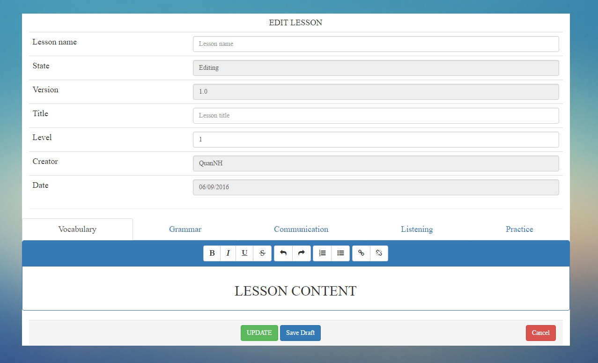

Figure 14. Editing Lesson page

|  |  |  |  |  |  |  |  |
| --- | --- | --- | --- | --- | --- | --- | --- |
| **No** | **Field name** | **Format** | **Require** | **Mandatory** | **Min**  **length** | **Max**  **length** | **Description** |
| 1 | Title | Text | Input | Y |  |  | User inputs lesson title |
| 2 | State | Text |  | Y |  |  | Displaying current state of lesson (auto-generated) |
| 3 | Version | Text |  | Y |  |  | Displaying version number of lesson (auto-generated) |
| 4 | Level | Dropdown box | Select | Y |  |  | User selects difficulty level of lesson |
| 5 | Date | Date |  | Y |  |  | Display created date of lesson (auto-generated) |
| 6 | Vocabulary | Text | Input | Y |  |  | User inputs the content of vocabulary section |
| 7 | Grammar | Text | Input | Y |  |  | User inputs the content of grammar section |
| 8 | Conversation | Text | Input | Y |  |  | User inputs the content of conversation section |
| 9 | Listening | Text | Input | Y |  |  | User inputs the content of listening section |
| 10 | Practice | Text | Input | Y |  |  | User inputs content of practice section |
| 11 | Update | Button | Click | Y |  |  | User clicks to submit the updated content |
| 12 | Save draft | Button | Click | N |  |  | User clicks to save contents as draft so that they can be re-opened next time |

Table 16. Editing Lesson page's component

### Question List

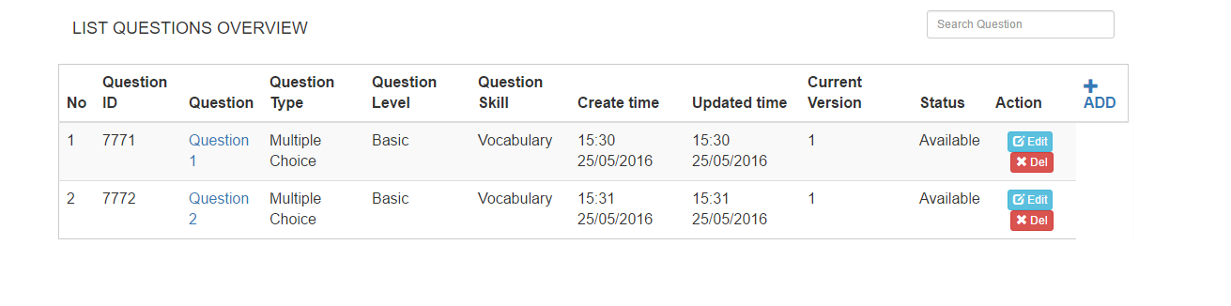

Figure 15. Question List

|  |  |  |  |  |  |  |  |
| --- | --- | --- | --- | --- | --- | --- | --- |
| **No** | **Field name** | **Format** | **Require** | **Mandatory** | **Min**  **length** | **Max**  **length** | **Description** |
| 1 | Question name | Hyperlink | Click | N |  |  | User clicks to display question content |
| 2 | Edit | Button | Click | N |  |  | User clicks to edit question content |
| 3 | Delete | Button | Click | N |  |  | User clicks to delete the question |
| 4 | Add | Hyperlink | Click | N |  |  | User clicks to add new question |

Table 17. Question List page's component

### Question Detail

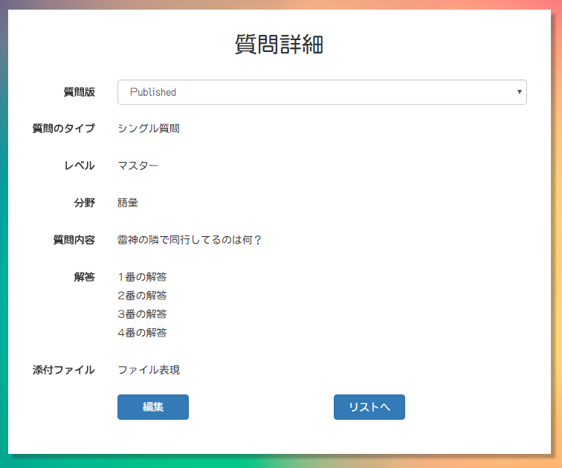

Figure 16. Question Detail

|  |  |  |  |  |  |  |  |
| --- | --- | --- | --- | --- | --- | --- | --- |
| **No** | **Field name** | **Format** | **Require** | **Mandatory** | **Min**  **length** | **Max**  **length** | **Description** |
| 1 | Edit | Button | Click | N |  |  | User clicks to edit question content |
| 2 | Back to list | Button | Click | N |  |  | User clicks to return to Question List page |

### Adding question

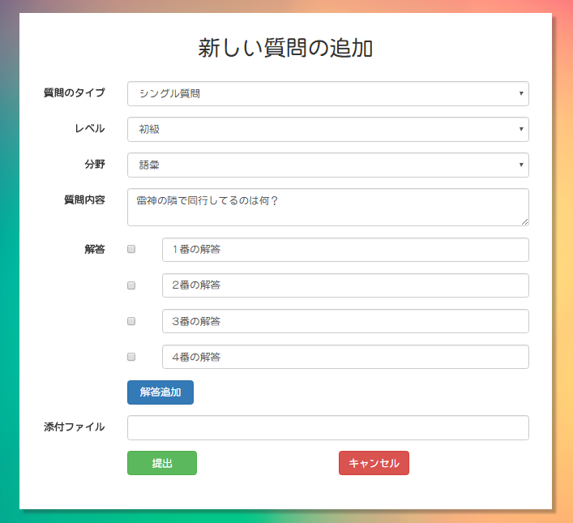

Figure 17. Adding Question page (single question)

|  |  |  |  |  |  |  |  |
| --- | --- | --- | --- | --- | --- | --- | --- |
| **No** | **Field name** | **Format** | **Require** | **Mandatory** | **Min**  **length** | **Max**  **length** | **Description** |
| 1 | Question type | Select box | Select | Y |  |  | User selects whether the question is single type or group type |
| 2 | Level | Select box | Select | Y |  |  | User selects difficulty level of question |
| 3 | Skill | Select box | Select | Y |  |  | User selects the skill of question |
| 4 | Question content | Text | Input | Y |  |  | User inputs the question content |
| 5 | Correct answer | Radio button | Click | Y |  |  | User clicks to decide the correct answer |
| 6 | Answer | Text | Input | Y |  |  | User inputs answer content |
| 7 | Add answer | Button | Click | N |  |  | User clicks to add one more answer |
| 8 | File attachment | File | Upload | N |  |  | User clicks to choose file and upload |
| 9 | Create | Button | Click | Y |  |  | User clicks the to submit the content and create new question |
| 10 | Cancel | Button | Click | N |  |  | User clicks to return to Question List page |

Table 18. Adding Question page's component

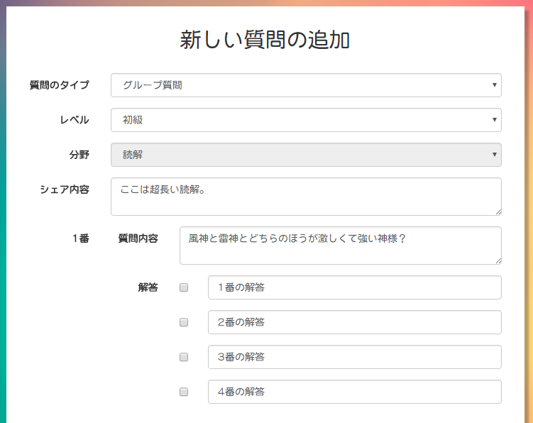

Figure 17. Adding Question page (group question) (1)

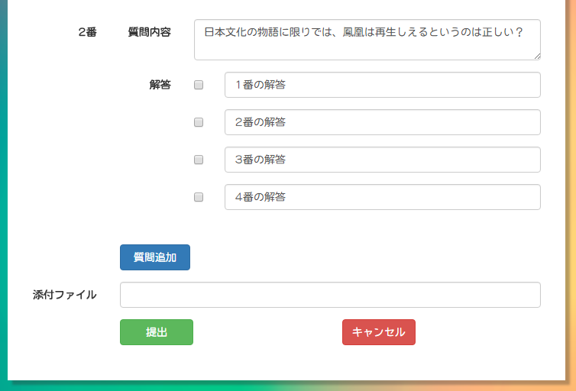

Figure 19. Adding Question page (group question) (2)

|  |  |  |  |  |  |  |  |
| --- | --- | --- | --- | --- | --- | --- | --- |
| **No** | **Field name** | **Format** | **Require** | **Mandatory** | **Min**  **length** | **Max**  **length** | **Description** |
| 1 | Question type | Select box | Select | Y |  |  | User selects the type of question to be added |
| 2 | Level | Select box | Select | Y |  |  | User selects difficulty level of question |
| 3 | Skill | Select box | Select | Y |  |  | User selects the skill of question |
| 4 | Shared content | Text | Input | Y |  |  | User inputs the shared content used by all questions |
| 5 | Question content | Text | Input | Y |  |  | User inputs content of a single question in group |
| 6 | Correct answer | Check box | Click | Y |  |  | User clicks to decide the correct answer(s) |
| 7 | Answer | Text | Input | Y |  |  | User inputs answer content of each question |
| 8 | Add | Button | Click | N |  |  | User clicks to add more question to the group |
| 9 | File attachment | File | Upload | N |  |  | User clicks to choose file and upload |
| 10 | Submit | Button | Click | Y |  |  | User clicks to submit the group question |
| 11 | Cancel | Button | Click | Y |  |  | User clicks to cancel adding and return to Questions List page |

Table 19. Adding Question page's component (group question)

### Editing Question

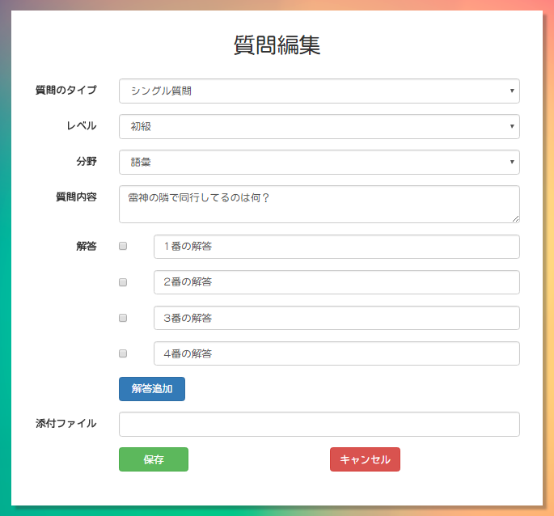

Figure 20. Edit Question page (single question)

|  |  |  |  |  |  |  |  |
| --- | --- | --- | --- | --- | --- | --- | --- |
| **No** | **Field name** | **Format** | **Require** | **Mandatory** | **Min**  **length** | **Max**  **length** | **Description** |
| 1 | Question type | Select box | Select | Y |  |  | User selects the type of question to be edited |
| 2 | Level | Select box | Select | Y |  |  | User selects difficulty level of the question |
| 3 | Skill | Select box | Select | Y |  |  | User selects the skill of question |
| 4 | Question detail | Text | Input | Y |  |  | User inputs question content |
| 5 | Correct answer | Radio button | Click | Y |  |  | User clicks to decide the correct answer(s) |
| 6 | Answer | Text | Input | Y |  |  | User inputs contents of selectable answers of a question |
| 7 | Add answer | Button | Click | N |  |  | User clicks button to add more selectable answers of the question. |
| 8 | File attachment | File | Upload | N |  |  | User clicks to choose file and upload |
| 9 | Create | Button | Click | Y |  |  | User clicks to submit the question content |
| 10 | Cancel | Button | Click | N |  |  | User clicks to go back to Questions List page |

Table 20. Editing Question page's component (1)

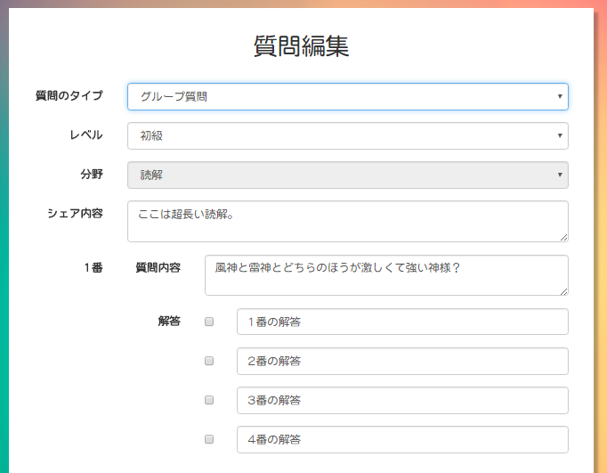

Figure 21. Add group question (1)

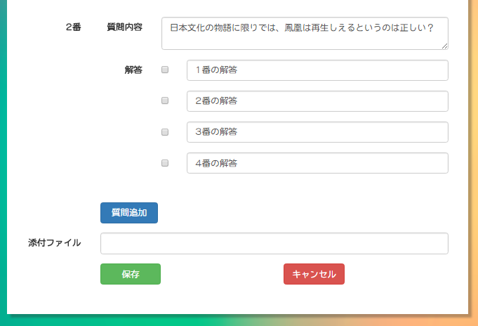

Figure 22. Adding Questio (2)

|  |  |  |  |  |  |  |  |
| --- | --- | --- | --- | --- | --- | --- | --- |
| **No** | **Field name** | **Format** | **Require** | **Mandatory** | **Min**  **length** | **Max**  **length** | **Description** |
| 1 | Question type | Select box | Select | Y |  |  | User selects the type of question to be edited |
| 2 | Level | Select box | Select | Y |  |  | User selects difficulty level of question |
| 3 | Skill | Select box | Select | Y |  |  | User selects the skill to be tested |
| 4 | Shared content | Text | Input | Y |  |  | User inputs the shared content used by all questions |
| 5 | Question content | Text | Input | Y |  |  | User inputs content of a single question in group |
| 6 | Correct answer | Check box | Click | Y |  |  | User clicks to decide the correct answer(s) |
| 7 | Answer | Text | Input | Y |  |  | User inputs answer content |
| 8 | Add | Button | Click | N |  |  | User clicks to add more question to the group |
| 9 | File attachment | File | Upload | N |  |  | User clicks to choose file and upload |
| 10 | Submit | Button | Click | Y |  |  | User clicks to submit group question |
| 11 | Cancel | Button | Click | Y |  |  | User clicks to cancel adding and return to Question List page |

Table 21. Editing Question page's component (group question)

## Content manager

## Admin

### Admin Dashboard

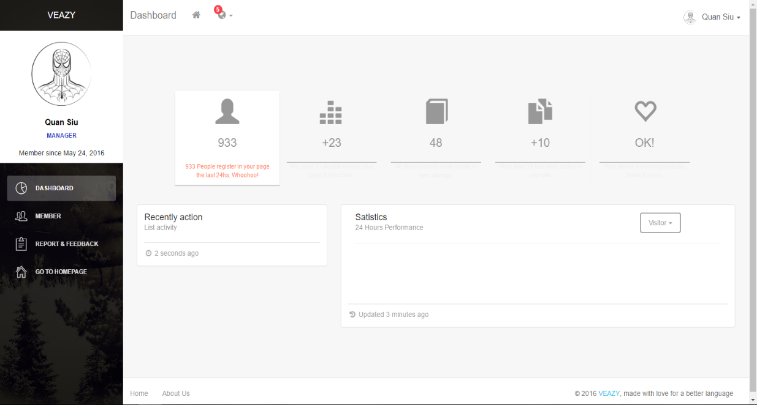

Figure 23. Admin Dashboard page

|  |  |  |  |  |  |  |  |
| --- | --- | --- | --- | --- | --- | --- | --- |
| **No** | **Field name** | **Format** | **Require** | **Mandatory** | **Min**  **length** | **Max**  **length** | **Description** |
| 1 | Member | Hyperlink | Click | N |  |  | User clicks to navigate to Member List page |
| 2 | Report & Feedback | Hyperlink | Click | N |  |  | User clicks to display list of reports & feedbacks |

Table 22. Admin Dashboard page’s component

### Member List

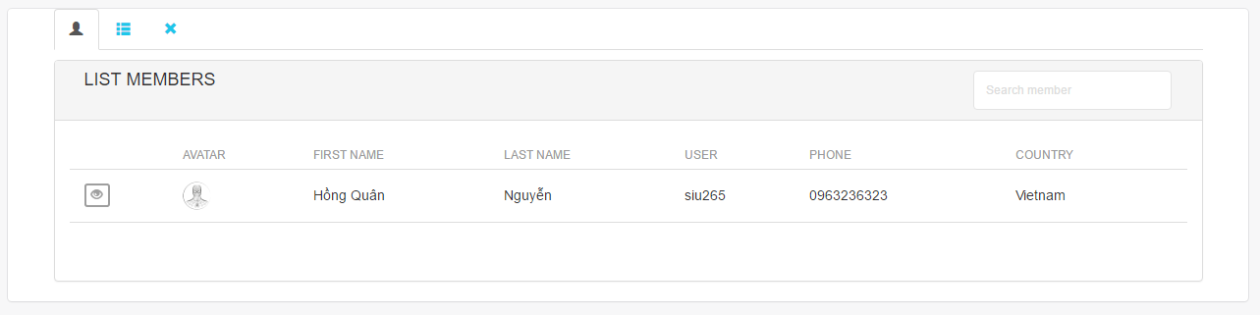

Figure 24. Member List page

|  |  |  |  |  |  |  |  |
| --- | --- | --- | --- | --- | --- | --- | --- |
| **No** | **Field name** | **Format** | **Require** | **Mandatory** | **Min**  **length** | **Max**  **length** | **Description** |
| 1 | Member list | Tab | Click | N |  |  | User clicks to display member list |
| 2 | Member list by role | Tab | Click | N |  |  | User clicks to display member list with respective roles |
| 3 | Banned member list | Tab | Click | N |  |  | User clicks to display banned member list |
| 4 | View detail | Button | Click | N |  |  | User clicks to display detailed information of members |
| 5 | Search member | Text | Input | N |  |  | User inputs a keyword to search |

Table 23. Member List page's component

### Report List

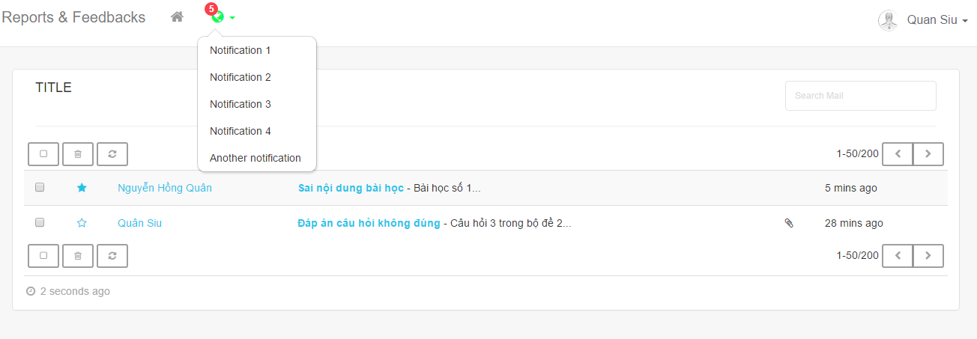

Figure 25. Report List page

|  |  |  |  |  |  |  |  |
| --- | --- | --- | --- | --- | --- | --- | --- |
| **No** | **Field name** | **Format** | **Require** | **Mandatory** | **Min**  **length** | **Max**  **length** | **Description** |
| 1 | Select all | Check box | Click | N |  |  | User clicks to select all reports |
| 2 | Delete | Button | Click | N |  |  | User clicks to delete selected reports |
| 3 | Reload | Button | Click | N |  |  | User clicks to reload list of reports |
| 4 | Right | Button | Click | N |  |  | User clicks to navigate to the next page |
| 5 | Left | Button | Click | N |  |  | User clicks to navigate to the previous page |

Table 24. Report List page’s component

# Other considerations

**N/A**